Chapter 1
C&C User Manual
Chapter Topics
Signing On 1-3
Changing the Password 2-6
Terminology 3-7
Changed Terminology 4-7
New Terminology 5-7
Page Navigation 6-9
Breadcrumbs 7-9
Page Action Buttons 8-10
Hyperlinks 9-11
Keyboard Alternatives 10-12
Navigation Bar or Scroll Area Header 11-13
Folder Tabs 12-13
Page Functionality 13-14
Job Control # 14-14
Multiple Requests Within The Same Job Control # 15-14
Replicate 16-15
Global 17-16
Scroll Bar & Elevator Button 18-17
Save or Submit? 19-17
Withdrawing a Request 20-18
Return for Additional Information 21-18
Repeating a Classification Action 22-18
Line Numbers and Number Ranges 23-19
Request Components vs. Sequence Components 24-19
Audit 25-19
Correction 26-20
Advanced Use of Correction Icon 27-21
Sunset Deadlines 28-21
Searches 29-23
Advanced Search 30-23
Basic Search 31-24
Favorites and Bookmarks 32-25
Canceling Transactions and Signing Out 33-26
Canceling Transactions 34-26
Closing Multiple Windows/System Sign Out 35-26

Signing On

Access the Page

- Access NYSTEP by clicking the NYSTEP  icon on your desktop and proceed to step # 5.
OR
- Open your Web Browser by clicking the Internet icon. (In this example Internet Explorer is being used.)
Your Internet home page will display.
- In the Address field, type the NYSTEP URL.

A Security Alert may display
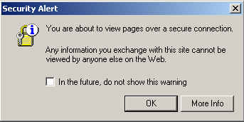

 | NOTE: | If you do not want this Security Alert to display each time you sign on, click in the In the future, do not show this warning checkbox and click OK.

Another Security Alert may display
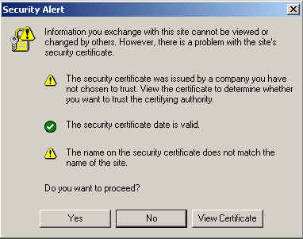
- Click Yes.
The PeopleSoft sign in screen will display
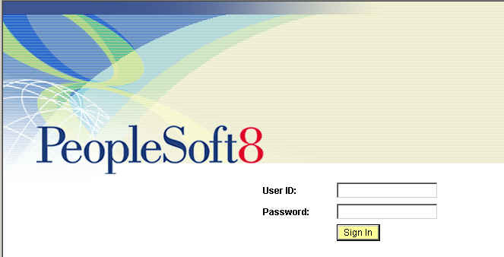
- In the User ID field enter your User ID in all capitals.
- In the Password field, enter your password (this field is case sensitive).

 | NOTE: | When a user logs onto the NYSTEP system for the first time, they will be directed to a series of dialog boxes that will require them to change their password.  See the section on “Changing the Password” later in this chapter.
- Push the Sign In button.
The NYSTEP Homepage will display.
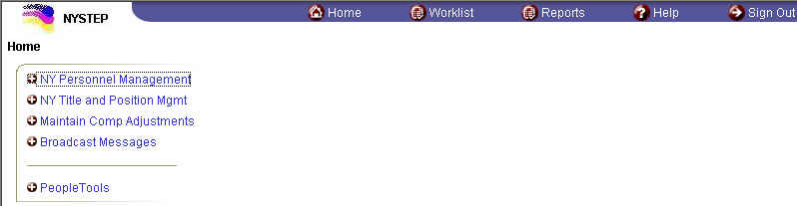
The icons on the top row include shortcuts to Home, the Worklist, Reports and Sign Out.

 | NOTE: | The Homepage is defined by the User’s profile. Therefore, the Homepage may look different from User to User.

The Menu Group can expand three columns per screen. As a user progresses to an application page, the three columns that are viewed will change to the last three selected.
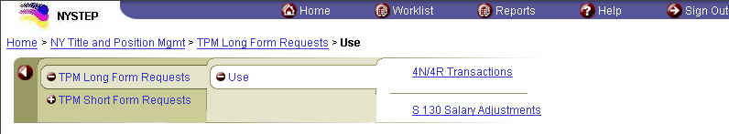
When clicked, brings the User back to a previous level.

A plus (+) sign in front of the menu option indicates that the menu option can be expanded. A minus (-) sign in front of a menu option indicates that the menu option is completely expanded.

 | NOTE: | To get a full screen view of the page, press F11. This will hide other toolbars that may be visible on your monitor. To return the toolbars, press F11 again.

Changing the Password
In accordance with the State Policy regarding the security of electronic data, the NYSTEP system will have the following password security:
Passwords must be a minimum of 8 characters in length;
At least one special character is required in each password. These special characters include: ! @ # $ % ^ & * ( ) - _ = + \ | [ ] { } ; : / ? . < >;
The system will require the password to be changed every 90 days;
The user will be locked out after 6 unsuccessful logon attempts, after which the Civil Service Help Desk must be called to allow the user back into the system;
The following Passwords will automatically be invalid in any form within the system: NYSTEP, PASSWORD, PA$$WORD and User ID. Any user that currently has any of these passwords will be directed to a Password Maintenance page to change their password.

Terminology
Some of the terminology has changed between the old NYSTEP System that was created in PeopleSoft 7.5, and the new Web Version that was created in PeopleSoft 8.3. Additionally, there is new terminology with which the user must be familiar.

Changed Terminology

PeopleSoft 7.5 | PeopleSoft 8.3
Page Groups | Components: A group of related pages that pertain to a specific task.
Go Menu Items | Home: Highest level in the menu navigation structure; this is also the default page when PeopleSoft 8.3 is accessed.
Prompts | Lookups: Functionality that takes the user to view tables that are associated with a field.
Page | Page: Area where data can be viewed or updated.

New Terminology

Term | Description
Breadcrumbs | Page navigation path. Appear as hyperlinks that allow the user to navigate between menu levels.
Browser | An application program that searches the Internet, interprets HTML and presents the Web page. Examples include Internet Explorer and Netscape Navigator.
HTML | Hyper Text Markup Language; the text based language used to construct Internet pages. The Web browser interprets this language to display the Web pages.
Hyperlinks | A highlighted and underlined word or phrase on a Web page that, when clicked, takes the user to another area on the same page or another Web page.
Page Action Buttons | Push buttons that allow the user to save updates, access records, navigate, and access other pages.
URL | Uniform Resource Locator; the address by which documents on the Internet are found.

Breadcrumbs

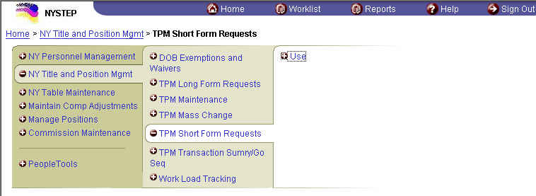
Menu Item
Menu Group

Page Navigation
There are several ways to navigate around a page. There are breadcrumbs, page action buttons, hyperlinks, keyboard alternatives, scroll areas, and folder tabs.

Breadcrumbs
Breadcrumbs indicate the path the user has taken to reach a page. They appear as a chain of hyperlinks which allow the user to navigate between menu groups.

Breadcrumbs

 | NOTE: | If a preceding breadcrumb is clicked, a message will display that asks if the User wants to save the current data first, or continue without saving.

Page Action Buttons
Page Action Buttons are push buttons that allow the user to save, update, access records, navigate and access other pages. Some Page Action Buttons only appear on certain pages or when certain actions are initiated.
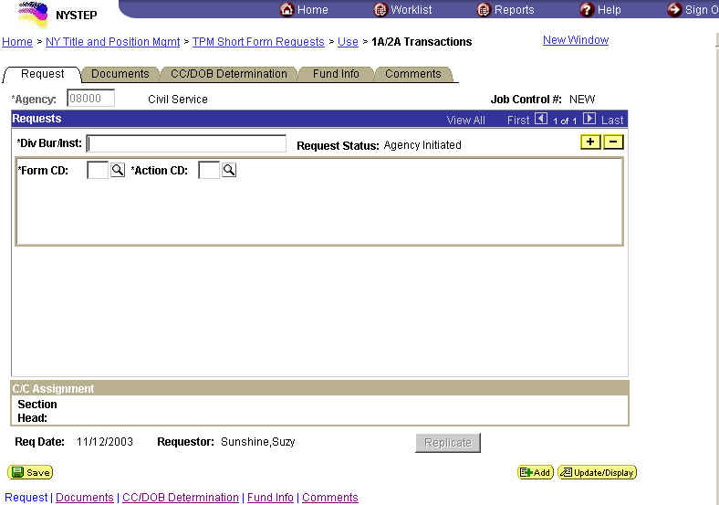
Page Action Button

Page Action Button | Description
 | Saves work and assigns a Job Control Number.
 | Next in List
 | Previous in List
 | Return to Search
 | Previous Tab
 | Next Tab
 | Update/Display
 | Include History
 | Correct History
 | Add another transaction of similar type.
 | Press to display a calendar for fields that require a date.
 | Delete a row
 | Insert a row
 | Indicates that there is a Lookup table of valid values for a particular field.

Hyperlinks
A highlighted and underlined word or phrase on a Web page that, when clicked, brings the user to another area on the same page or to another Web page.

Hyperlinks

Keyboard Alternatives
Keyboard alternatives are another way of navigating through the pages. They assist users in quick data entry.

Keys | Functions
Alt + 1 | Save
Alt + 2 | Return to Search
Alt + 3 | Next in List
Alt + 4 | Previous in List
Alt + 5 | Search or Lookup
Alt + 6 | Cancel
Alt + 7 | Insert Row
Alt + 8 | Delete Row
Alt + 0 | Exit
Alt + F | Find in List
Ctrl + Z | Undoes the last field typed.
Shift + Tab | Brings the user to the previous field.
Shift + End | Highlights the whole field when the cursor is at the beginning of the line.
Shift + Home | Highlights the whole field when the cursor is at the end of the line.
Alt + . | Next in grid, scroll, or search page results list.
Alt + , | Previous in grid, scroll, or search page results list.
Alt + \ | Toggles between “Add a New Value” and “Find an Existing Value” in a search page.
Alt + / | Find data in grid or scroll.
Alt + ‘ | View all rows of data in grid, scroll area, or search page results list.
Ctrl + K | When in a search or transaction page, opens a page with a list of keyboard navigation shortcuts using hot keys and access keys.

Navigation Bar or Scroll Area Header

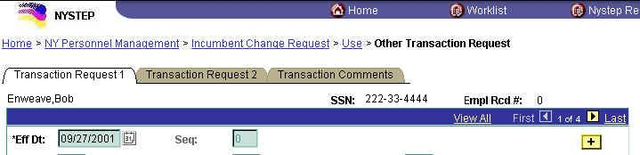
Navigation Bar or Scroll Area Header

The scroll area header allows the User to scroll through multiple rows of data. The View All hyperlink allows the User to view and scroll through all the data rows together. The First hyperlink brings the User to the first (the most recent) row of data. The 1 of # shows the User how many rows of data exist for the transaction. The Last hyperlink brings the User to the last (the oldest) row of data. To view one row at a time, use the arrow to the right of First and the arrow to the left of Last to navigate back and forth between rows.

Folder Tabs
Each type of transaction is called a component. A component can be made up of one or several pages. Each page is displayed by a folder tab. When the folder tab is clicked, the page in the component will display.
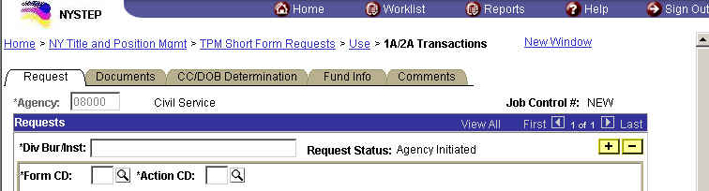
Folder Tab

Page Functionality

There are some standard features on the TPM pages. The top of each page has the Agency Code and name. This is the first field entered by the user. If security grants access to only one agency, the agency will be populated by the system. If access to more than one agency is available, a drop down box lists the agency codes available to the user. A job control number, and possibly a sequence number field, is located in the right hand corner of the page. The information at the bottom of a page includes the transaction request date and the requestor’s name.

Job Control #
The Job Control # is located in the upper right hand corner of all pages. It is used for tracking a transaction, the sequential numbering of multiple requests in a classification transaction, and accessing a request for review or approval.
The Job Control # consists of 9 digits. The first four denote the fiscal year, and the five numbers following the dash are a sequential number assigned by NYSTEP to the request after a “Save” or “Submit” action. The Job Control # reads “NEW” until that action.
For transactions containing multiple requests, a sequence number is used to represent the different portions of the whole transaction. The sequence number will appear as “1 of 1” until more sequences are added.

Multiple Requests Within The Same Job Control #
NYSTEP can be used to process more than one request within the same Job Control # and Div Bur/Inst. For this function, Alt + 7 key or Insert Row icon is used.
By way of illustration, presume an agency needs to request two new positions – one Clerk 1 and one Keyboard Specialist 1. Begin by accessing the appropriate classification action page, the 1A New Positions request. Once all the information requesting the Clerk 1 has been entered, place the cursor in the highest numbered sequence and press Alt + 7 or Insert Row icon.
At this time, NYSTEP displays a fresh page over the first request. The sequence number changes from “1 of 1” to “2 of 2”. Enter all of the data necessary for the Keyboard Specialist 1 position on the second page. When the data is entered and all edit checks have been passed, the classification action request can be saved or submitted.

 | NOTE: | The scroll area header allows the User to scroll through multiple rows of data. The View All hyperlink allows the User to view and scroll through all the data rows together. The First hyperlink brings the User to the first (the most recent) row of data. The 1 of # shows the User how many rows of data exist for the transaction. The Last hyperlink brings the User to the last (the oldest) row of data. To view one row at a time, use the arrow to the right of First and the arrow to the left of Last to navigate back and forth between rows.

The Insert Row icon can be used to overlay a fresh page up to 99 times within the same Job Control #, as long as the request has not been submitted.
If the added request is later deemed unnecessary, that portion of the transaction request can be deleted using Alt + 8 or Delete Row icon prior to submitting. Place the cursor in a data entry field within the sequence to be deleted. Press Alt + 8 or the icon and a confirmation message will appear. Click OK. That page is deleted from the transaction, although the sequences are not renumbered.

Replicate
For multiple sequences within a request, the user can work with Alt + 7 or Insert Row icon on the toolbar, as described above. The User may also use the Replicate button for certain transactions to duplicate data from one sequence to another.
The replicate button appears for transactions 1A 31, 2A, 4N 11, 4N 12, 4R 01, 4R 02, 4R 41 and 4R 42. When the Replicate button is pressed for any of these transactions, the system will save the transaction, insert a new row, and roll forward all the values from the last sequence entered. The system will blank out the # POS Req, Begin Line Number, and Location fields. These fields must be re-entered by the user.
The button is available only on the request page and only prior to the submission of the transaction. The row being replicated must have passed any and all save edits prior to the replication taking place. Using this feature eliminates redundant data entry for multi-sequenced transactions when the only difference between them is the line numbers, location, or the number of positions required. Sequences added by Replicate can be deleted as described above.

Global
The Global  button is designed for larger, multi-sequenced transactions in which the same action applies to all sequences. The Global button will allow for various fields to be filled once, depending on the type of transaction being worked, and applied to all sequences within the job control number.
The button is located at the bottom of the CC/DOB Determination page, and is available only to C&C users. When the button is clicked, a message window will appear asking for confirmation of a global action.
Global action confirmation box
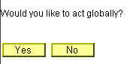
Clicking Yes will bring up the Global Field Values box. The data fields in this box are dependent on the type of request being acted upon.
Sample Global Field Values entry box
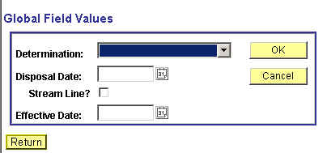
Enter the appropriate values into the box and click OK. The values entered into this box will then propagate to each sequence within the transaction. If it is decided that a global action is unwanted and the request has not yet been submitted, clicking the Cancel button will clear the global action.
The Disposal Date field is grayed unless Deny or Withdrawn is selected. For these actions, the system will fill in the data with the current date. This can be modified.
If the Streamlined? Flag is checked, the effective date defaults to the Proposed Effective Date and is open for modification. If the flag is not checked, the effective date is grayed.

 | NOTE: | If necessary, a Global action can be taken, and then specific data may be changed at the sequence level. For instance, a ten-sequence transaction is submitted and all are to be approved, but two are streamlined. Use the global function to approve all transactions, then scroll to the two sequences to be streamlined and check the streamlined flag. It should be noted that Global changes override any action already taken at the sequence level.

Scroll Bar & Elevator Button
Scroll bars allow the user to display more data than can be shown at any one time on the page. By clicking on the arrows, the elevator button contained in the scroll bar can be moved up and down to scroll through the applicable area. Dragging the elevator up or down the scroll bar (click, hold and drag) can also change the display. Should there be more data than can fit into a page; the elevator button will be located at the top of the scroll bar. Pages may provide more than one scroll bar for access to information specific areas of a page.
When a scroll bar is present in a work area, additional data can be entered. The Alt + 7 function key or the Insert Row icon is used to create additional entry fields.
Place the cursor in any data entry field within the area. Press Alt + 7 or the Insert Row icon. This will activate a new data entry field.
To delete a data entry field that has been added through Alt + 7, Alt + 8 or the Delete Row icon is used. Place the cursor in the data field to be removed, and press Alt + 8 or Delete Row icon. When pressed, a confirmation message will pop up asking if the data should be deleted. Confirm your action by pressing the “Yes” button on the message screen. The data will be deleted from the transaction.

Save or Submit?
After completing a classification action request, one of two things must happen.
When the data is correct and complete and any required documents have been attached, press the Submit button to commit the request to NYSTEP. The request is forwarded to the next approval level. Once a request has been submitted, it cannot be accessed for changes. If changes are necessary, contact the appropriate DOB Examiner or the TPM Corrections Unit.
If there are questions about the data, click Save . This secures the transaction data without submitting and allows the user access to the request through the worklist for later revision and/or submission.
NYSTEP will not allow an incomplete page to be saved or submitted. All required data entry fields must be completed, and all field edit checks passed.

Withdrawing a Request
It is possible for the wrong data to be entered into a request, pass all the edit checks, and be forwarded to the next approval level for consideration (reclassifying or moving a position and entering the wrong line item number, for instance). It is also possible that circumstances change and the agency wants to change the request.
When these or other errors occur, or when a transaction request needs to be cancelled outright, it can be withdrawn from NYSTEP, provided that the request has not received final approval. When an agency contacts an Analyst to withdraw a request to make a simple correction, i.e. change the item number, the Analyst should evaluate whether to withdraw the request or make the change to the Request page using the Correction  icon and note the reason for the change in Comments. Note: Once the Correction icon has been used and the change(s) saved on the Request page, it is no longer available for use on that request.
When the agency wants to reconsider a request that is pending at C&C or there is other reason to withdraw the request, select Withdraw on the Determination page and provide appropriate documentation.
The request is returned to the Worklist of the Requestor. The data can be corrected and the transaction resubmitted, or the request can be removed from the Worklist by marking it worked.
A request that has passed through C&C and been forwarded to the Division of Budget can also be withdrawn, again providing that it has not received final approval. Contact the DOB Examiner, who withdraws the request and returns it to C&C. C&C can then return the transaction to the requestor.

Return for Additional Information
There are times when C&C may request additional information. This action returns the request to the requestor and puts it on that person’s Worklist. Once the additional information is attached, the request can be resubmitted. Note: the agency cannot change data on the Request page in this status.

Repeating a Classification Action
The same type of classification action request can be repeated as often as necessary without having to initiate the request through the drop down menus. This can be done using the Add icon.
After submitting (or saving) a request page, press the Add icon. A new request page with NEW in the Job Control # field appears. Enter the data for the new transaction, save or submit the request, and the Job Control # is assigned.
This function can be used as often as necessary to process classification request of the same nature. This is especially useful for those agencies within New York State that have their personnel and classification actions completed by a central office.
A central office can initiate a request for a position in one facility, press the Add icon, and request a position for another facility.

Line Numbers and Number Ranges
In transactions that require the number of positions being requested and a beginning line number, an edit and calculation is performed by NYSTEP. When multiple positions are requested, the ending line number is calculated by NYSTEP, and an edit is initiated verifying that the attributes of the positions within that range match.
If the attributes of all of the positions are not identical, an error message indicates the “attributes of Range of Line Items are not the same.” Attributes are defined as the title, salary grade, jurisdictional class and the negotiating unit of a position. Find where the discrepancy lies and either alter the number of positions being requested, or the line item numbers.
To assist in processing the request, some pages have a View Position button that allows the user to access a list of the line items and their attributes. After viewing the positions, press the Return to page button to return to the transaction request page.

Request Components vs. Sequence Components
Comments added on the Comments page can be attached to a transaction request at two different levels.
Any comment attached at the higher Request level is pertinent to all of the sequences created for that transaction. Comments that apply to only one sequence can be entered at the sequence level. They are visible only at the sequence to which entered unless “View All” is selected.

Audit
The majority of agency submitted transactions are routed to C&C for approval and/or further routing. If, at any stage of the processing, a C&C Analyst makes any change to the original request, an Audit hyperlink will appear on the original request page.
When clicked, an audit page will appear that lists the original values for the specific data elements that have been changed. The changed elements can be viewed on the request page itself.
The Audit hyperlink will appear only if C&C has made a change to a 1A, 2A, 4N, or 4R transaction.

Correction
Designed specifically for C&C, the Correction functionality provides the C&C user the ability to change defined fields on a submitted request that are not modifiable on the determination page.
If a request is opened and the Correction icon is available, there have been no changes done to the original request and modifications can be made. Clicking the Correction icon will bring the user to the request page, where those data fields that are not available on the determination page are opened for modification.
The fields that C&C can modify are defined by transaction. Fields that can be potentially changed and displayed when modified are: Form Code; Action Code; Proposed Effective Date; Proposed Expiration Date; Total Positions Requested; Begin Line Number; Position Duration; Duration Number Of Months; Position Jobcode; Jobcode; Requested Title Code Description; Requested Title Code Grade; Requested Title Code Jurisdictional Class Code; Requested Title Code Union Code; Location; Proposed Rate Frequency; Proposed Salary Grade Equivalent; Proposed Not To Exceed Rate; Proposed Hourly Rate; Proposed Annual Rate; Change To Location; Change To Agency ID; and Change To Begin Line Number.
If an Analyst changes the Form Code and/or Action Code, the business rules for the new codes are executed.
If the Form or Action Code is changed, the page blanks out all enterable fields except Agency, Div Bur/Inst, Job Control #, Sequence, Request Status. Changes to the open fields can be made.
When any field has been changed, an Audit hyperlink will appear on the Request page (see above). When clicked, an audit page will appear that lists the original values for the specific data elements that have been changed. The changed elements can be viewed on the request page, and if applicable, the Determination page.
If a field applies only to the original request, it will show on the Audit page. Conversely, if the field applies only to the Changed To request, it will show on the audit page as being changed from 'blank'.
If the correction does not change either the Action or the Form Code:
If Location, Changed From Beginning Line #, or Changed to Beginning Line # is changed, the original fields are not blanked out. Rate frequency fields and rate fields should only be blanked out if the condition requiring them no longer exists.
For Long Form transactions:
- 4N 11 & 4N 12 transactions allow the changing of fields that may affect rate or rate frequency.
- If only Location, or Line # are being changed, the rate and rate frequency fields should not be open for modification.
- For all 4R transactions and 4N 13s, there are no fields to change that will require changing the rate frequency or rate.

Short Form Transactions:
- 1A 31, 2A 71, 72, 73 and 2A 74 act the same as 4N 11 and 12.
- 1A 13 and 2A 74 are not applicable.
- If only Location or Line # are changed, the rate and rate frequency fields should not be open for changing.

If the Line # Range has been changed, the attributes of the positions must be re-checked. Only the attributes of the new Line #’s will be stored.

Advanced Use of Correction Icon
The Correction Icon, when pressed, allows the user to make changes to a limited number of fields. Analysts wishing to change more fields than allowed can delete the Action Code. When the Action Code is deleted and reentered, the page blanks out and the user is allowed to input all the agency fields, except Agency, Div/Bur/Inst, Job Control # and Request Status.

 | NOTE: | The Audit page will reflect only the values that were changed. For example, if you delete the Action on a 4N and reenter the same Item Number, the Audit page will not show that Item Number was changed.

 | WARNING: Before changing the Action Code and blanking out the page, make sure you have the original values that the agency requested.

 | NOTE: | A Classification & Pay Analyst will see either the Correction icon or the Audit button, never both.

Sunset Deadlines
NYSTEP has a limit, or “sunset,” on the amount of time a transaction can sit inactive in the system.
Withdrawn transactions are returned to the Requestor and placed in the Worklist. The transaction is held in the worklist for a period of 60 days, then purged from the system. The transaction can be removed from an individual’s work list prior to the 60-day sunset by marking the item worked. Transaction requests that have been in a worklist for 180 days at DOB are withdrawn from DOB and marked “Sunsetted”.

Searches
There are two types of Searches that can be used to retrieve data; an Advanced Search and a Basic Search.

Advanced Search
This is the default search. By using the Advanced Search, the User may search by entering data in multiple fields, and any combination of fields. To do a basic search, click the Basic Search hyperlink.

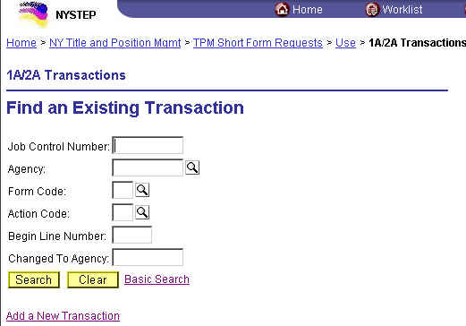

Basic Search
When using the Basic Search, the User can retrieve data by entering data in a single field. The Search By dropdown field allows the User to select the value used to search. The User can switch to the advanced search by clicking on the Advanced Search hyperlink.

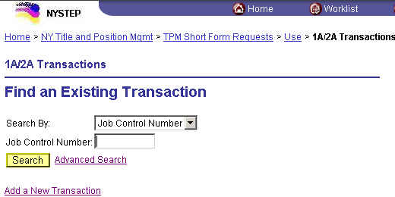

Whether using an Advanced or Basic Search, partial value searches can be used by entering partial values in a particular data field. As with the old NYSTEP System, the more data entered, the more precise the returned list will be. Of course, entering the Job Control Number will bring up only that transaction.

Favorites and Bookmarks
Internet Explorer allows a user to create a shortcut that goes directly to a specific web page. These shortcuts, called “Favorites” make it easier to access the transaction types that are used most often. The Favorites that are marked are specific to a workstation, not a User ID.
To mark a transaction type as a Favorite in Internet Explorer:
- When a transaction type is open, click Favorites, Add to Favorites.
A dialog box will display
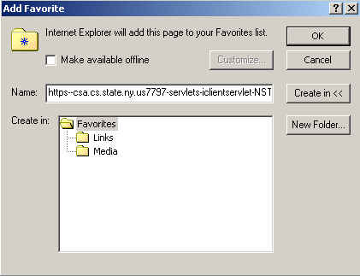
- In the Name field, enter the type of transaction or other descriptive title.
- Click OK.

 | NOTE: | Currently, Netscape does not allow for the creation of shortcuts, or “Bookmarks” within NYSTEP.

Canceling Transactions and Signing Out

Canceling Transactions
In the new NYSTEP System, there is no longer the icon to cancel a transaction. To cancel a transaction without saving or submitting, a user has different options.
- Click on a preceding breadcrumb to bring you back to a previous point in the navigation.
- Click on a hyperlink at the bottom of the page.
- Click on to bring you back to the list.
- Click the Home icon at the top of the page.
- Click the Sign Out icon on the top of the page to end the session.

When canceling a transaction without saving or submitting, a dialog box will display the following reminder:
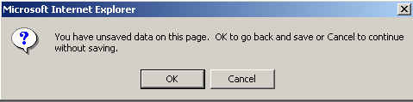
Click Cancel to continue without saving.

Closing Multiple Windows/System Sign Out
Certain processes within NYSTEP will result in other pages appearing on the user’s monitor (Reports, Transaction Summary, Work Load Tracking).
To close an individual page, simply press the button in the upper right hand corner of the page. This will close that particular page, yet leave any other pages open and the system up to process other transactions.
Using the icon will close out the system and log the user out, ending the NYSTEP Session and bringing the User back to the sign in page. Use this method only when signing completely out of the system!
Once back at the Sign-in page during log out, the user can use the File drop down menu to close out the web browser entirely. Access the drop down menu and click Close. This will disconnect the user from the web.


