DRAFT OF MEMO FROM APPOINTING AUTHORITIES TO ALL STAFF

TO: All staff
FROM: [Appointing Authority]
DATE:
RE: Updates to statewide workforce demographic data collection
The Department of Civil Service (“DCS”) has expanded self-identification options and updated demographic data collection methods for New York State employees. Updates include expanded options in gender, ethnicity/race, language, LGBTQ+, disability, and veteran status. Additionally, effective January 2023, DCS launched a web app that enables employees to complete and submit their demographic information via an online form.
Employees are encouraged to access the web app to update their demographic data on record and can access this form here. Employees can also navigate to the web app by going to www.cs.ny.gov, scrolling to the footer of the page, and under “Resources,” click on the “Demographic Data Self-Identification Form” link (see screenshot below).
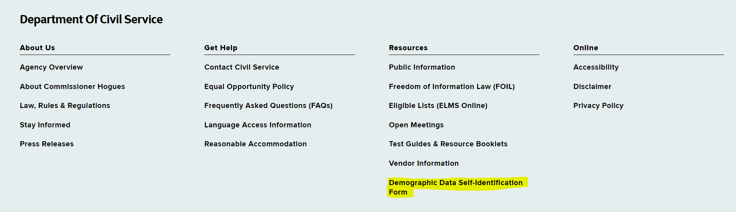
You must log in using your personal my.ny.gov account. Once logged in, you will be taken directly to the form to complete and submit. Upon successful submission, a note will display confirming your successful submission of information (see screenshot below).
You may also access the web app using the following QR code:
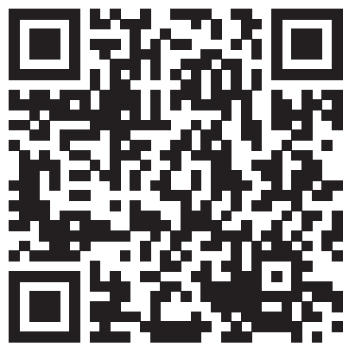
For questions about this data collection initiative, please contact [enter agency D&I Liaison contact information].
For any technical issues with accessing the online demographic data form, please contact the IT Help Desk at 844-891-1786 or fixit@its.ny.gov.
For anyone requiring a physical version of the form, please contact [enter agency HR office contact information].

